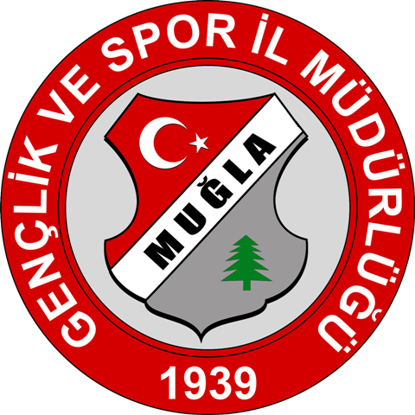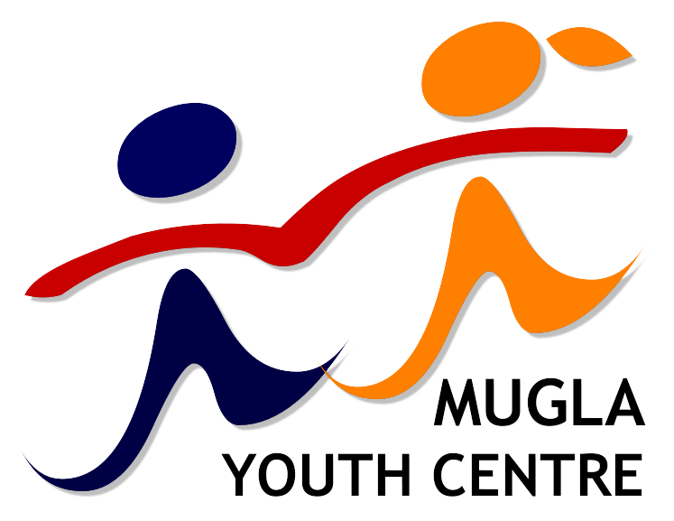
“Mission EVS”
Action 3.1b

Project name: “Mission EVS”
Topics: European awareness, Youth policy
Project dates: 24-31 October 2012
Place: Muğla / TURKEY
Organization: Mugla Youth Centre
Participants: 6 organizations from EU states and 6 organizations from non-EU states; 2 partcipants from each organization.

Aims:
• To enhance the cooperation between organisations within the Action 2 - European Voluntary Service and Action 3.1 - Cooperation with the Neighbouring Partner Countries of the Youth in Action Programme between Programme Countries and six Eastern Partnership countries (Armenia, Azerbaijan, Belarus, Georgia, Moldova, Ukraine);
• To promote new opportunities for international youth cooperation withinEastern Partnership Youth Window;
• To develop new project on inclusion of young people with fewer opportunities living in rural or deprived urban areas;
Objectives:
• Bringing together people working with young people in order to create new project ideas within the Youth in Action Programme;
• Creating an atmosphere of common understanding between people representing different cultures, working styles, etc.;
• Providing knowledge about the possibilities of cooperation within the Youth in Action Programme with special focus on Eastern Partnership Youth Window;
• Presenting examples of efficient and successful cooperation within Eastern Europe and the Caucasus;
• Building new partnerships between Programme countries and partners from Eastern Europe and the Caucasus with a clear commitment to provide support to young people with fewer opportunities living in rural or deprived urban areas;

How to apply:
If you work with EVS and you are interested in this project please fulfill attached “Part III” form and send us scanned copy (signed and stamped) till 30 March 2012.

Contact person: Ibrahim Dikici
Phone number: +902522131627
Email: muglaprojects@gmail.com

